Selecting genes for mutant study

Goal – select mutant for coculture and growth experiment. Based on mutant library of *Alteromonas* MIT1002

# Selecting differentially expressed genes

Selection criteria: Based on the RNASEQ and proteome of *Alteromonas* HOT1A3 growth in coculture with and *Prochlorococcus*. Prefer genes that are consistently upregulated and/or from pathways that are upregulated. Concentrate on the later timepoints (so, upregulated on days 30,60,90 vs day 7).

Upregulated genes:

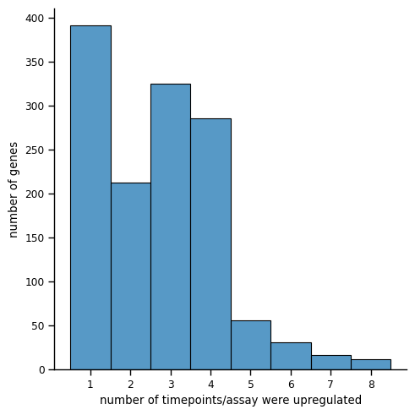

Based on this distribution, select genes upregulated in at least 5 timepoints/assays.

|  |  |  |  |  |  |
| --- | --- | --- | --- | --- | --- |
| Category | KO | Upregulated (number of timepoint/ assay) | Num DE In Cat (example) | Num In Cat | Num mapped to mutants |
| Metabolism | 00240 Pyrimidine metabolism [PATH:ko00240] | 4 | 7 | 33 | 2 |
| Metabolism | 00910 Nitrogen metabolism [PATH:ko00910] | 3 | 8 | 13 | 4 |
| Genetic | 03010 Ribosome [PATH:ko03010] | 3 | 36 | 54 | 1 |
| Metabolism | 00280 Valine, leucine and isoleucine degradati... | 2 | 19 | 26 | 3 |
| Metabolism | 00300 Lysine biosynthesis [PATH:ko00300] | 2 | 8 | 16 | 3 |
| Metabolism | 00362 Benzoate degradation [PATH:ko00362] | 1 | 9 | 11 |  |
| Metabolism | 00071 Fatty acid degradation [PATH:ko00071] | 1 | 12 | 18 |  |
| Metabolism | 00500 Starch and sucrose metabolism [PATH:ko00... | 1 | 12 | 18 |  |
| Metabolism | 00061 Fatty acid biosynthesis [PATH:ko00061] | 1 | 14 | 20 |  |
| Metabolism | 00780 Biotin metabolism [PATH:ko00780] | 1 | 7 | 12 |  |
| Metabolism | 00195 Photosynthesis [PATH:ko00195] | 1 | 7 | 8 |  |
| Metabolism | 00740 Riboflavin metabolism [PATH:ko00740] | 1 | 7 | 11 |  |
| Metabolism | 00900 Terpenoid backbone biosynthesis [PATH:ko... | 1 | 8 | 14 |  |
| Metabolism | 00190 Oxidative phosphorylation [PATH:ko00190] | 1 | 14 | 38 |  |

Based on this list, select pathways that are enriched in upregulated genes in at least 2 timepoints/assays. Not sure about Ribosome and also not sure about the amino acid pathways.

This logic selects 114 genes based on their upregulation and 144 genes because they are in upregulated pathway (regardless of their individual differential expression). Which selects a total of 248 genes.

We can limit to selecting genes in pathways that are also upregulated at least once (99 genes). Which selects **203 genes** total.

If we need to limit further can change padj cutoff (currently 0.05), can also take into account logFC (currently not used).

Next, used ROS KO list to locate ROS enzymes, total 16 found.

Exoenzymes are more complicated and currently I haven’t looked into.

|  |  |  |  |  |  |
| --- | --- | --- | --- | --- | --- |
| Selection | Upregulated genes | Genes in upregulated pathways | ROS genes | Total number of genes |  |
| Upregulated genes and all genes in upregulated pathways | 114 | 144 | 16 | 263 |  |
| Upregulated genes and upregulated genes in upregulated pathways | 114 | 99 | 16 | 218 |  |
| MIT1002 genes | 110 | 99 | 16 |  |  |
| Mutants found in the library (based on row 2) | 20 | 13 | 2 | 33 |  |